Question 1. Fitspiration is an online trend where a message (usually an image of a thin and muscular person with a motivational quote) is displayed that encourages viewers to push themselves to exercise in order to change their physical appearance. Although these messages were intended to have a positive influence, researchers hypothesized that regularly viewing images that focus on changing physical appearance could actually cause negative effects and even eating disorders like anorexia. To test this hypothesis, the researchers identified 100 followers of fitspiration Instagram accounts and sent them an anonymous survey that asked them to indicate “How many days a week do you view a fitspiration Instagram account” on a scale of (1 day to 7 days) and “How satisfied are you with the shape of your body” on a scale of 1 (not at all satisfied) to 7 (very satisfied). (30 pts)

1. In this study, what are the two constructs being tested and how are they operationalized? (4 pts)
2. What statistical test would the researchers perform to test their hypothesis? Based on the scales the researchers used in the study, what direction is the effect that the researchers are expecting to observe? (6 pts)
3. The researchers are considering the conclusion that looking at fitspiration causes eating disorders. Why can't they infer causation in this study? What are two other possible explanations for data showing a relationship between their variables? (6 pts)
4. How does the method of selecting the participants affect conclusions that could be drawn from this study? (4 pts)
5. Describe a study that could be run in the lab that would allow a causal inference to be made if the results were reliable (e.g., with a t-test). You may use the same DV but change and specify the IV and (briefly) the procedure. (6 pts)
6. If you were to run the more controlled study from (e) in a classroom setting, list two ethical considerations you would have to consider (4 pts)

Question 2: Fries et al. (2019) wanted to know whether including irrelevant “seductive details” (interesting facts about the material unrelated to the learning objectives) in classroom lectures would increase student learning. In addition, they thought that the effect would be limited to conditions where the learning was important, defined as “high stakes” environments. Participants were university students who scored below average on a knowledge quiz about matrix algebra. Participants were randomly assigned to watch a lecture about matrix algebra that either included 7 interesting, irrelevant facts or did not. Additionally, half of the participants were given a high stakes context where they could receive a $10 bonus for good performance, they would be filmed so researchers could evaluate their learning behaviors, and at the end they would have to stand at the board and explain their answers to the group. The “low stakes” group (the other half of the participants) was told they were evaluating the content to help out the university (low stakes). All participants watched the lecture and then completed an 8-question matrix algebra test and their percent of correct answers on the test was calculated. (40 pts)

1. What are the 3 constructs being studied in this experiment? How are they being operationalized? (6 pts)
2. Diagram the independent/dependent variables and their level(s) (6 pts)

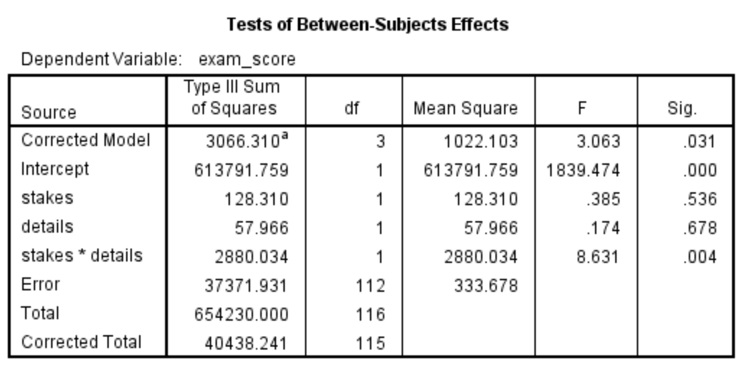Question 2 continued. The following is an SPSS ANOVA output for the above experiment:

1. Give the APA-style statistical report for and evaluate the two main effects of the study (note: just the main effects, the interaction term is the next section) (10 pts).
2. 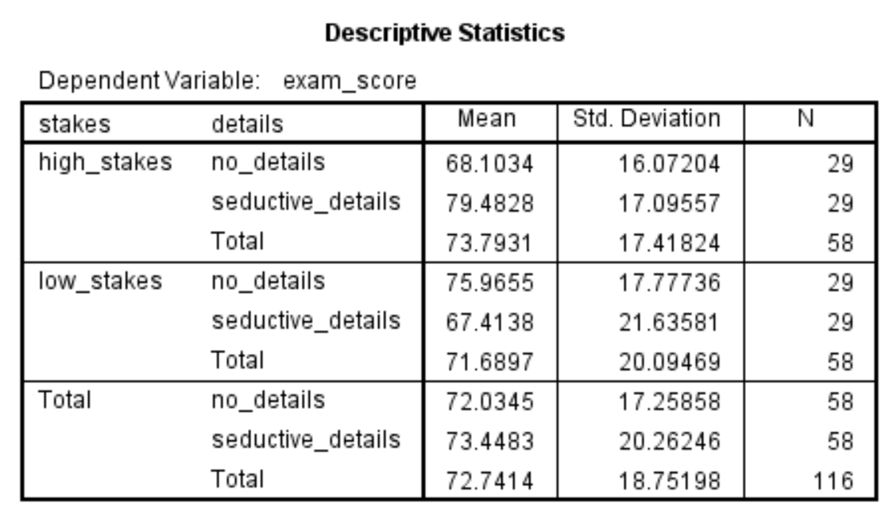Give the APA-style statistical report of the interaction between variables and describe the form and direction of interaction between IVs. Use the descriptive statistics provided in the SPSS-style formatted table below to see what the interaction term reflected in the data (8 pts).
3. The authors argue that they are simulating an educational environment with their high-stakes manipulation, how similar is this to a real-education environment? List one way it is similar and one way you would be concerned that it differed (4 pts)
4. The study used specific selection criteria to identify participants for the study (low pre-knowledge of matrix algebra) and only tests one type of classroom material (matrix algebra). Explain how each of these components of the study potentially affect the researchers’ ability to generalize their results and why (6 pts).

Question 3. Do emotions influence moral judgments? Previous research suggests that feelings of disgust increase how negatively people feel about minor moral transgressions. Horberg et al. (2009) compared the effect of feeling disgust with feeling sadness on moral judgments. One hundred twenty-two undergraduates completed the experiment in a small laboratory room. Participants were assigned to view either a disgust-inducing film or a sadness-inducing film and then read a short vignette about a student who refused to lend lecture note to a classmate who missed class due to illness. Participants judged “Did the student do an immoral or wrong thing in not lending the lecture notes?” with a yes/no response. (30 pts).

1. What are the IV and DV for this study? What statistical test would be used to assess the statistical significance of the effect? (6 pts)
2. What problem would be faced be the researchers interpreting the results if both disgust and sadness had similar effects on the moral judgment? What needs to be added to the design to address this? (4 pts).

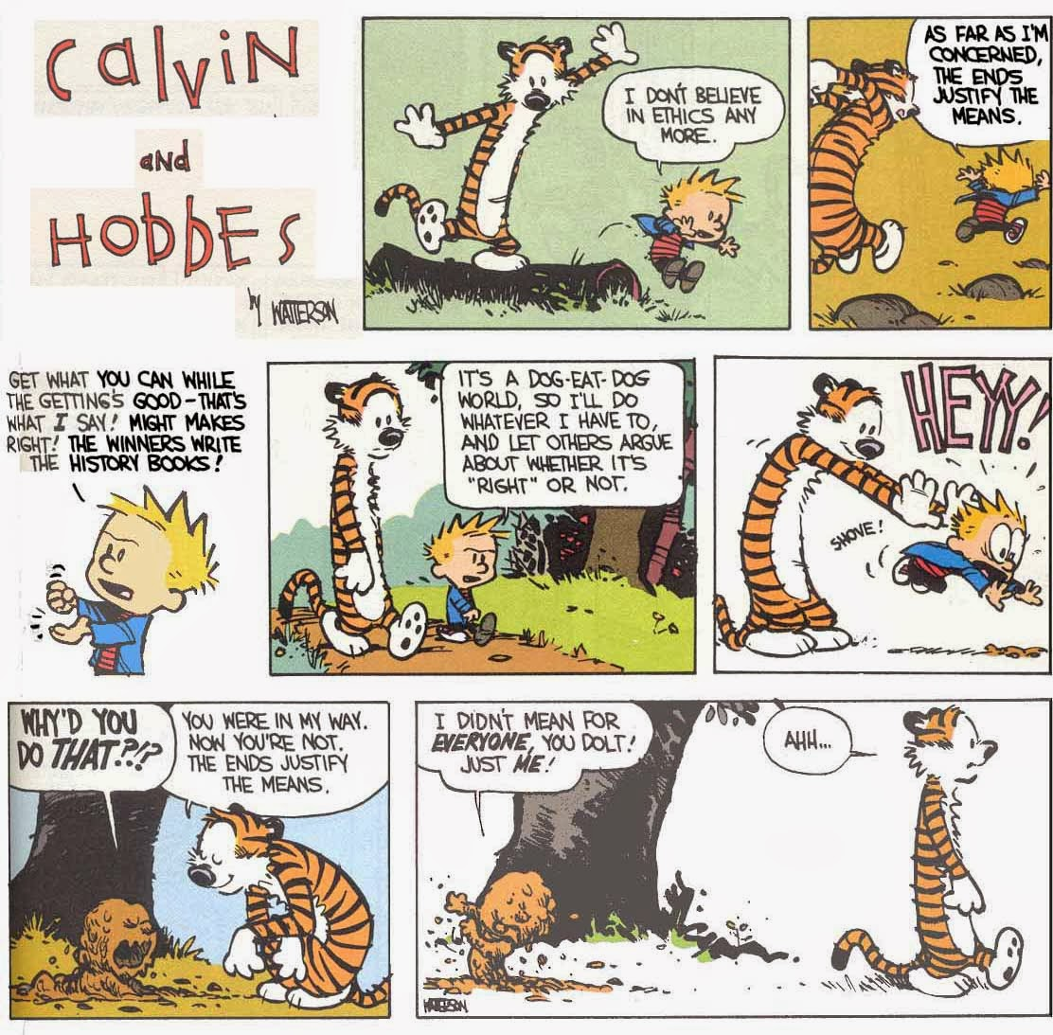

1. The researchers further conjectured that the effect of emotion would be particularly strong when the kind of moral transgression being judged by participants. Feelings of disgust are thought to be particularly important for transgressions related to purity and/or cleanliness. Design a factorial study to test the idea that moral judgements are more severe when the emotion and transgression match. You can use the mood manipulation from above but outline new transgression descriptions and change the DV to one that would be suitable for an ANOVA analysis. (8 pts)
2. Graph the results of the study if they were consistent with the hypothesis. If you are unsure exactly what the hypothesis from (c) is supposed to be, write a note with your hypothesized results next to the graph (4 pts).

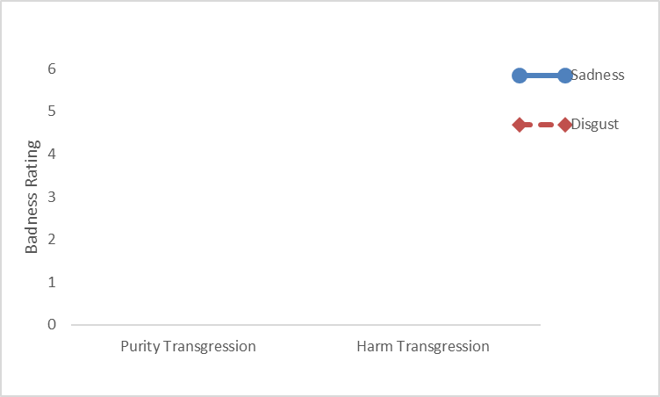

1. After the participants watched the sad or disgusting video, they also answered a mood survey that assessed how disgusted, sad, and angry the participants were. As expected the disgust film induced more disgust and less sadness than the sad film. However, participants who watched the disgust film also rated themselves as angrier than the sad film participants. How would this change the interpretation of the results? (4 pts)
2. Edward is one of the research assistants conducting this study. He recognizes one of the research participants as a friend from his Psych110 class and saw that student didn’t rate the moral transgression as being very upsetting. Later, together with mutual friends, he jokes about his friend’s response on the study as indicating he doesn’t have very strong moral feelings. What ethical concerns are relevant to this situation? What could Edward do to avoid violating those concerns? (4 pts)